Save The Date!
WEEK #1 June 2-6, 2025* *Florida Sheriffs Youth Ranch Camp
WEEK #2 June 9-13, 2025
8:00AM – 5:00PM

HEROES
Summer Camp
Children’s Safety Village
910 Fairvilla Rd, Orlando, FL, 32808

$250 week #2

The Heroes Summer Camp is for children
ages 6 -12. Space is limited.
Extended care is available for an additional fee

For more information,
call 407-521-4673.

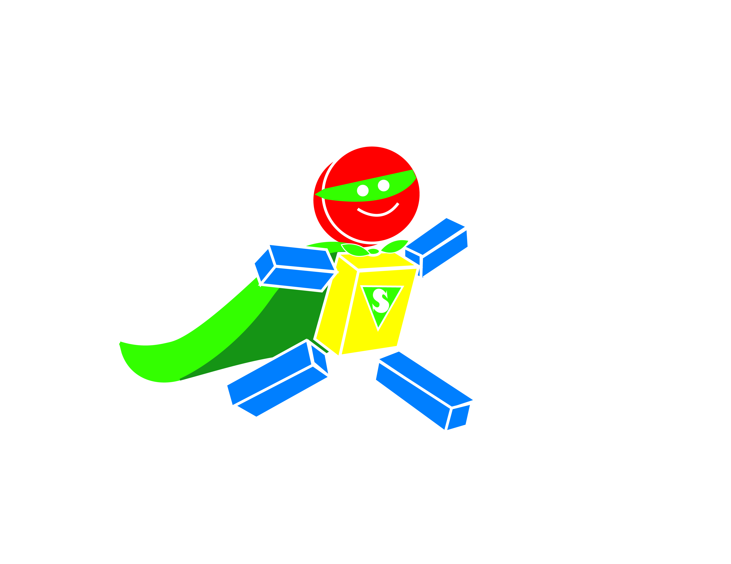

FUN, GAMES, ARCHERY, PAINTING, CRAFTS, & MORE!

BIKE SAFETY - Learn about bike and traffic safety, best helmet fitting tips.

WATER SAFETY- Learn basic water safety tips, & rescue techniques from outside the water.

BASIC FIRST AID - Learn basic first aid skills and how to take action in case of an emergency.

FIRE SAFETY- Learn how to make an exit plan and what to do if a fire occurs in your home.

HOME & LIFE SAFETY – Learn about injuries that most often occur inside the home and important safety skills to help safeguard your home.

Heroes Summer Camp
June 9-13, 2024 8:00am-5:00pm
One registration form per child. Forms may be photocopied.
Child’s Name: |  |  |  | Age:
Parent’s Name:

Address: |  | City: |  |  | Zip:
Home Phone: | Work Phone: |  | Cell Phone:
Email Address:

___ My child has a special need and/or allergy. (Please indicate :_________________________________________________________________________________________________)
___ My child CAN / CANNOT swim without a life vest. (Please circle one)
___ If available, I would like my child to participate in free swim lessons (the on-site swim instructor will determine child’s skill level and need of lessons)
My child,________________________________________, has my permission to participate in the Children’s Safety Village of Central Florida, Inc Heroes Summer Camp program. I waive and release all CSV staff, members of the Board, OCSO, vendors, volunteers, sponsors and anyone involved in the program from any claim or liability in the event of injury or death.
In the event that my child may require medical and/or surgical care if I am unable to be reached, I hereby give my consent to medical and/or surgical treatment to ____________________________________ (hospital) and doctor _________________________________ or his/her designee to provide this care. I agree to pay all the costs and fees contingent on any emergency medical care and/or treatment for my child as secured or authorized under this consent.
My child has permission to be photographed/ videotaped for use by the Children’s Safety Village of Central Florida, Inc. and its promotion. ____________________ Initials
Daily snacks are provided Monday thru Friday during Heroes Summer Camp. Campers MUST bring their own lunch & can bring snacks if they do not wish to participate in provided snacks or have special dietary needs. Lunch must be self-contained in non-refrigerated lunch box.
A deposit of $50 is required for each child with this application upon registration. The deposit will be deducted from the final cost. Deposits may not be refunded or transferred to any other program. The full payment is due May 26, 2025.
Attendance of a Parent Orientation Meeting is required for camp participation. A Virtual Orientation is scheduled Tuesday May 27 from 12pm-1pm or Tuesday May 27 from 4pm-5pm (chose one time to attend). A meeting link will be sent out ahead of time. Campers are welcome to attend Orientation with parents.
EXTENDED CARE: The Children’s Safety Village offers extended care from 7:30am-8:00am or 5:00–5:30 p.m. at $30 additional cost.
Late pick-up policy fee: For pick-up after designated extended care time (5:30pm) or 5:00pm, a fee of $1 per minute will be charged/per child.

Signature of Parent/Guardian: | Date:

Deposit: □$50.00/child (applied toward registration for week#2)  Registration: □$0.00/child /per week #1 : June 2-6 □$250.00/child /per week #2 : June 9-13  Orientation Meeting: □ 12pm-1pm □ 4pm-5pm  Extended Care Week #2 ONLY HOURS: Morning 7:30am-8:00am , Afternoon 5:00pm-5:30pm  □Morning $30/child □ Afternoon $30/child □ both $30/child  METHOD OF PAYMENT: ___Cash ____Credit Card/ Debit Card  Credit Card Number____________________________________________________ ____Visa ____MasterCard _____ 3 Digit Code______  Name as it appears on the card___________________________________________________________ Or Call 407-521-4673 for payment by phone  Exp. Date _____________ Total Amount Paid ___________________ Week #1_____ Week #2_____ (Please check weeks attending) | Send Registration to:  Children’s Safety Village of Central Florida, Inc.  910 Fairvilla Rd  Orlando, FL 3208  Email Registration to: childrenssafetyvillage@gmail.com  Fax Registration to: 407-521-4676  For more information, call 407-521-4673. 

